Travelling Salesman Problem (TSP)

Aim
To implement the Travelling Salesman Problem (TSP) using Python and find the shortest possible route that visits every city exactly once and returns to the starting city.

Objective
- To understand the concept of TSP.
- To find the minimum-cost route among a set of cities.
- To visit each city exactly once.
- To return to the starting city with minimum total distance.

Algorithm
Brute Force / Permutation Method
- Start with a distance matrix representing the distances between cities.
- Select the first city as the starting city.
- Generate all possible permutations of the remaining cities.
- Calculate the total distance for each possible route.
- Add the distance from the last city back to the starting city.
- Compare all route distances.
- Select the route having the minimum distance.
- Display the shortest route and its total distance.
Flow Chart:
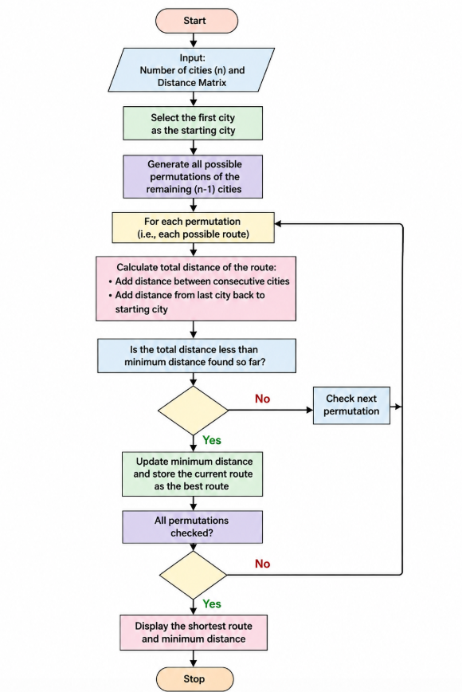
Code:
from itertools import permutations

dist = [
[0, 10, 15, 20],
[10, 0, 35, 25],
[15, 35, 0, 30],
[20, 25, 30, 0]
]

cities = [0, 1, 2, 3]
start = 0

min_distance = float('inf')
best_route = None

for route in permutations(cities[1:]):
current_route = (start,) + route
total_distance = 0

for i in range(len(current_route) - 1):
total_distance += dist[current_route[i]][current_route[i + 1]]

total_distance += dist[current_route[-1]][start]

if total_distance < min_distance:
min_distance = total_distance
best_route = current_route

print("Shortest Route:")
print(" -> ".join(str(city + 1) for city in best_route) + " -> 1")
print("Minimum Distance:", min_distance)
Output:
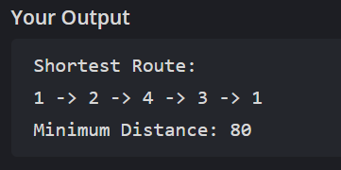
Result:
Thus, the Travelling Salesman Problem (TSP) was successfully implemented using Python. The shortest route was found as:
City 1 → City 2 → City 4 → City 3 → City 1
with a minimum total distance of 80 units.

